Field Trip at the Shiawassee Basin Preserve – July 22, 2017

A small group of adventurous OAS members attended the Shiawassee Basin Preserve field trip in Springfield Township on July 22. The weather was overcast and rainy. Eight birders gathered at the beginning of the field trip, but light rain reduced the number to seven when the group hit the trail. The Shiawassee Basin Preserve is owned and operated by Springfield Township Parks and Recreation. The Preserve consists of 514 acres of natural areas and several miles of trails.
It is the home of one of Michigan's largest, most pristine prairie fens. Fens are unique wetlands fed by groundwater and associated with the headwaters of streams, lakes and rivers. Fens are rare and one of the most biologically diverse habitats in the world. Rare communities of unusual plants are found in fens along with endangered animals. The SB Preserve is home to the Eastern Massasauga Rattlesnake and Poweshiek skipperling, both endangered. During the hike the group observed several butterflies identified by expert – Doris Applebaum, including Pearl Crescents, Wood-Nymphs, Monarchs and Cabbage White.
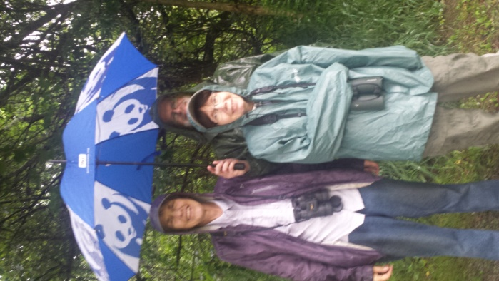
Thirty-nine species of birds were seen before the rain downpours dampened everyone’s enthusiasm. A bird checklist has been reported on eBird. Surprise birds seen were the Yellow-billed Cuckoo and the Pied-billed Grebe.
Thanks to everyone attending, sharing their expertise and braving the elements.

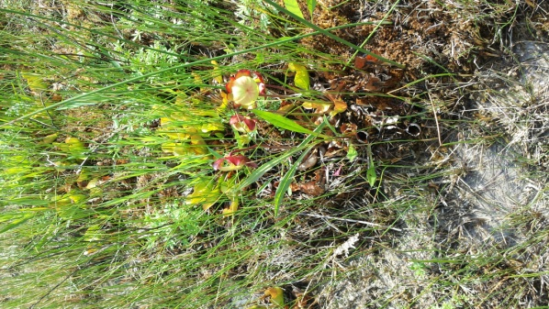

Blanche, Gail and Phil chilling

Pitcher-plant

