Oakland Owlets’ Christmas Bird Count at Eagle Valley 2023

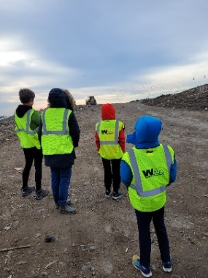
The Oakland Owlets families and friends participated in the 124th Christmas Bird Count on December 16, 2023, at Eagle Valley in Orion Township. This was the fourth year that the young birders’ club joined this historical bird count. The Christmas Bird Count is one of the oldest conservation activities in North America. The Oakland Owlets were invited to Eagle Valley which is a landfill owned and operated by WM. Along with the property being an operational business, it also maintains a wildlife habitat area. Eagle Valley is a magnet for many species of birds. Scavengers visit the site for food scraps which in turn attracts predators that prey on the large concentrations of birds. Eagle Valley is a wonderful place for young birders to see large predatory birds hunting and hanging out. The group was not disappointed.
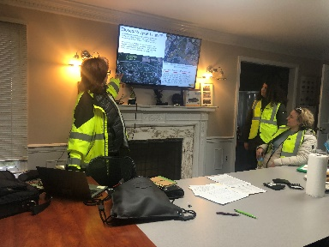
The Oakland Owlets are grateful to WM for making this field trip possible. Eagle Valley is a restricted area serving the community with recycling and waste disposal services. Arrangements were made in advance to tour Eagle Valley with Community Representative Kathleen Klein. Ms. Klein is a wonderful educator who tirelessly works to share the story of the site to the community. Eagle Valley is a certified Wildlife Habitat recognized through the Wildlife Habitat Council.

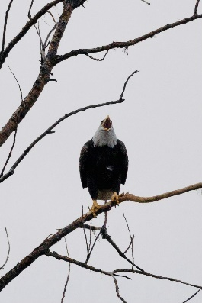
Our group gathered in the office before birding. Ms. Klein shared a brief presentation about the site along with WM’s work to protect the environment and set aside wildlife habitat at Eagle Valley. Afterwards, the group carpooled to drive to key points to view birds. In a brief time, we found two Adult Bald Eagles and an immature Bald Eagle along with a small flock of Wild Turkeys. These large birds were easy to see even at a distance. The Bald Eagles perched in the branches of the tall tree while the Wild Turkeys foraged on the ground under the trees. Everyone learned quickly that Eagle Valley is appropriately named.

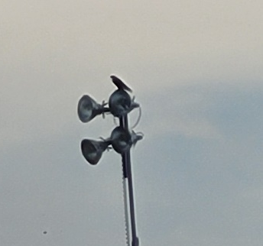
After viewing these magnificent birds, we car caravaned deeper into the landfill and to a higher elevation. Although the landfill was closed, birds were actively gathering near any exposed areas in search of a meal. The number of birds concentrated in some locations was phenomenal. These gatherings included several species of gulls and numerous European Starlings. These birds are known for their scavenging skills. We stopped again to watch the Bald Eagles soaring overhead. While watching, someone noticed another large bird perched nearby on a light post. This bird was watching stealthily and waiting for an opportunity to snatch a bird in flight. Its shape and profile were the distinctive of a large falcon. We were all amazed to see a Peregrine Falcon.

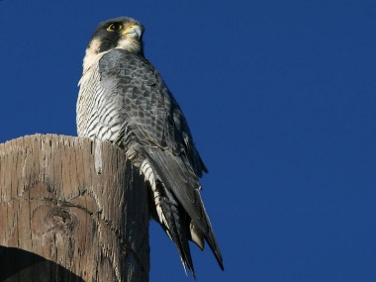
The Peregrine Falcon is a rare bird which required extra documentation and it was the only Peregrine Falcon seen on this year’s CBC. Peregrine Falcons are one of the birds that benefited from the Endangered Species Act. Extirpated throughout the area, captive bred Peregrine Falcons were successfully fledged from hacking boxes in the Northeast in the 1970’s and the results can be seen today with the return of Peregrine Falcons.

The group travelled to another part of the landfill at a lower elevation. Along the drive we stopped and watched a Bald Eagle harass a flock of Canada Geese along the hillside. The geese were unmoved by the eagle diving at them. Two other members of the CBC field team joined the group as we drove to the wetlands on the east side of the property. WM maintains mitigated wetland areas.
The group stopped and walked along the edge of the wetland where we encountered several songbirds not found on the open faces of the landfill. The wetlands were bordered by trees and surrounded by vegetation. Our Eagle Valley checklist increased with American Robins, Mourning Doves, and American Tree Sparrows along with a few other species. The final tally at Eagle Valley was 22 species and 1545 individual birds observed.

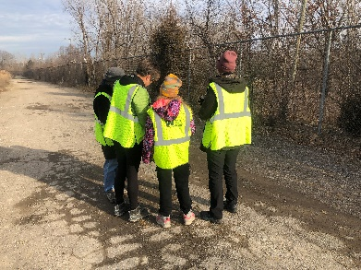
A special thank you to Kathleen Klein and the WM staff at Eagle Valley for making this tour possible. CBC observers for this area continued to bird nearby through the day. Thanks to CBC team members – Kathleen Dougherty, Mike Dougherty, Dan Badgley, and Ed O’Brien. The final CBC report in the Oakland Audubon CBC area tallied 73 species. To see the complete Oakland Audubon CBC report, visit the Oakland Audubon field trip webpage.

Photo Credits: Kathleen Dougherty, Heather Klish, Kathleen Klein, and OAS Gallery.

