Field Trip Report – Detroit River – Lake Erie Shoreline Field Trip – Jointly with Grand Rapids Audubon Club
October 26, 2024
Leader: Don Burlett

This field trip was a collaboration between Oakland Bird Alliance (OBA) and Grand Rapids Audubon Club as suggested by Audubon Great Lakes. It was a gloriously sunny and cool day to be out birding. The group of 12 birders gathered at the Detroit International Wildlife Refuge and began the day birding the Humbug Marsh area. As the first stop of the day, the birds were very active and swirling around. We immediately began seeing young Cedar Waxwings and many Rusty Blackbirds. We soon found lots of Golden-crowned Kinglets feeding in the area. Raptors and herons/egrets were to be found along with droves of American Robins and White-throated Sparrows. Several Hermit Thrushes were seen, often chasing the robins as they fought over available berries in the woods. Water levels in the region were quite low and the only shorebirds found here were Killdeer. We also enjoyed the return of the Dark-eyed Juncos.
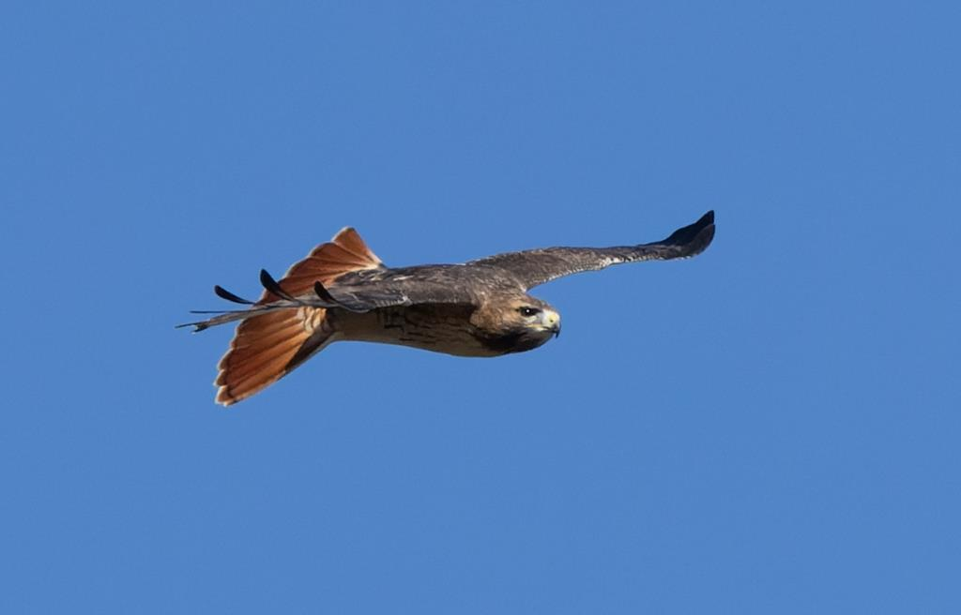
Red-tailed Hawk (photo by Malissa Bossardet)

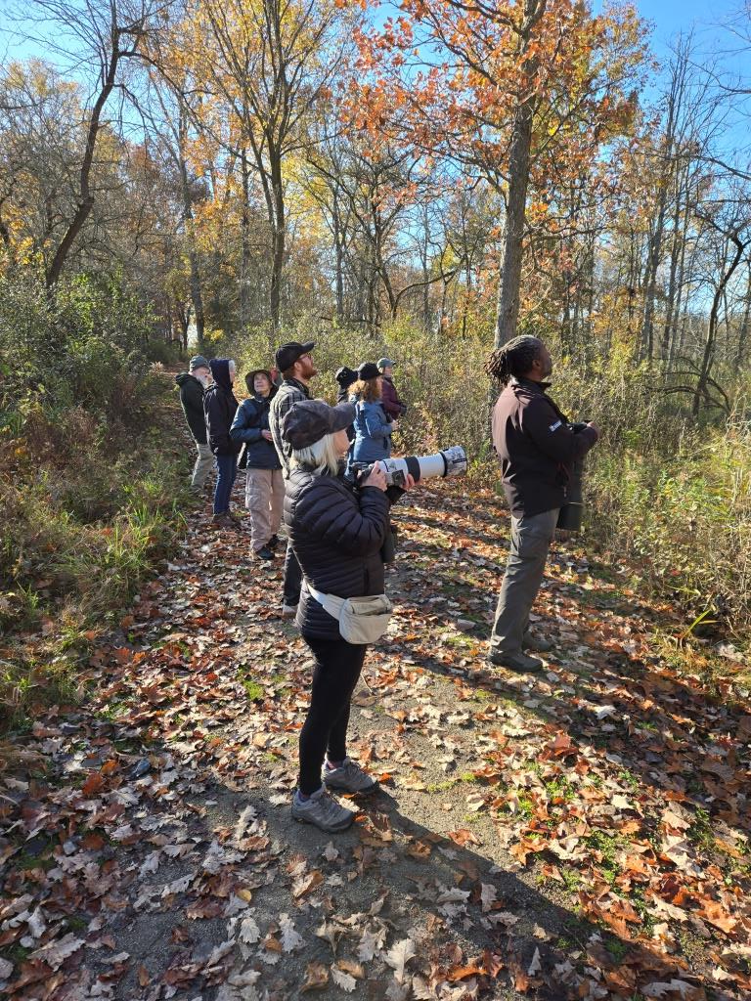
The Group at Humbug Marsh (photo by Don Burlett)

We then drove to Lake Erie Metropark and began by birding the Marshland Museum trails. Things began to get quiet quite quickly in the morning but there were birds to be found. We spotted some Greater Yellowlegs on the way in and found lots of Great Egrets and Great Blue Herons in the areas. The normally well watered channels were closer to mud flats, but some Wood Ducks, Mallard and Pied-billed Grebes kept us busy with identification. More Golden-crowned Kinglets were buzzing around with some Ruby-crowned Kinglets and Black-capped Chickadees. We also observed a flight of American Crows moving along the river in this area.

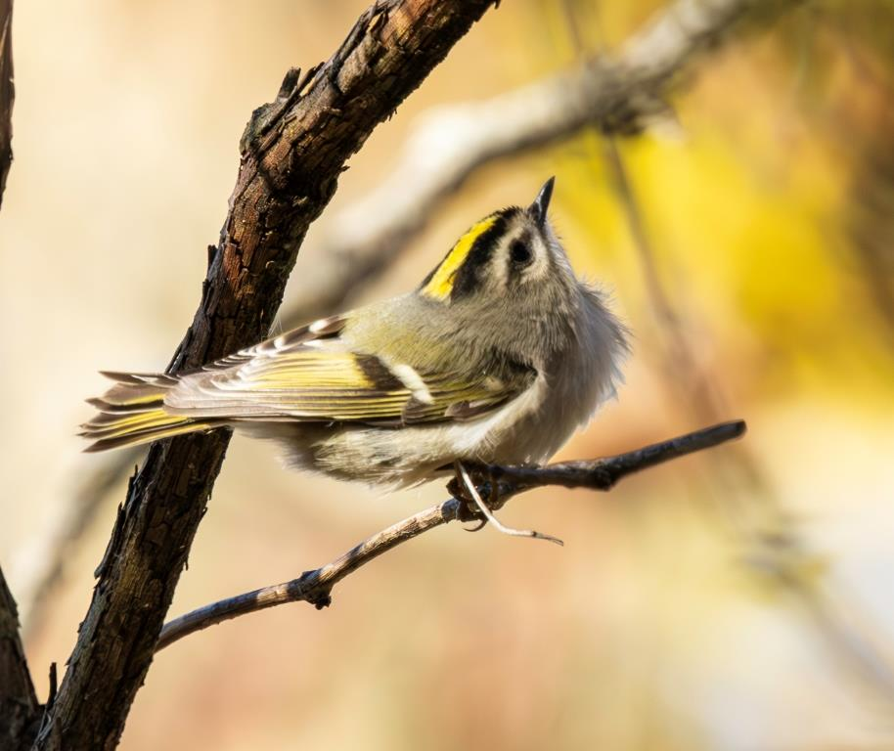
Golden-crowned Kinglet (photo by Malissa Bossardet)
We then moved over to the Hawk Watch site at Lake Erie Metropark. We had the opportunity to watch the “professionals” identifying raptors as quite large distances. It wasn’t a huge day for movement, but some Eagles, Turkey Vultures and Sharp-shinned Hawks were seen in the area. We were provided informational packets by the volunteers there, provided additional insight into the work they do.
The final stop involved a drive south to Sterling State Park. Here, we found a large number of Bonaparte’s Gulls, where they obviously found the habitat inviting. We walked around a large impoundment where we found Swans (Mute and Trumpeter) and a number of duck species. About the only passerine species we saw were Yellow-rumped Warblers and a few other species scattered about.

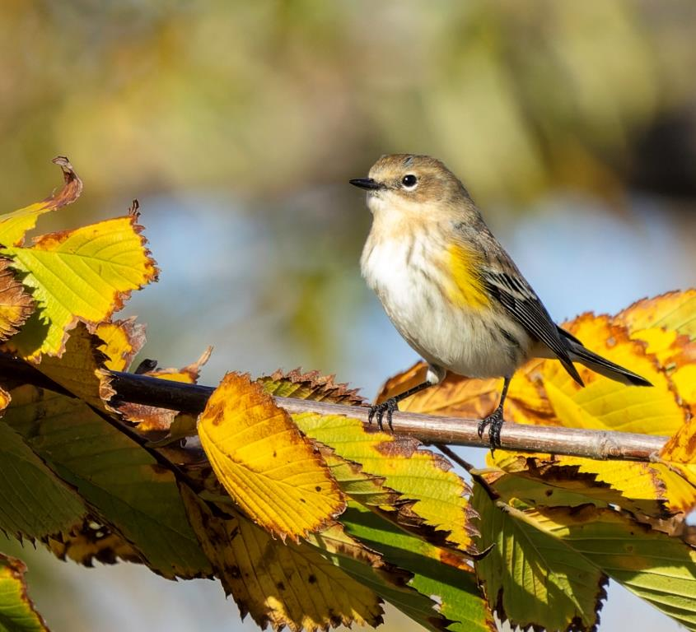
Yellow-rumped Warbler (photo by Malissa Bossardet)

We concluded our day after walking about 5 miles of trails and about 6 hours of birding. It was great fun, and we enjoyed the day together as a group. A complete list of the species seen (54 species) is provided at the end of the report. And we were all smiles after this wonderful day of birding.

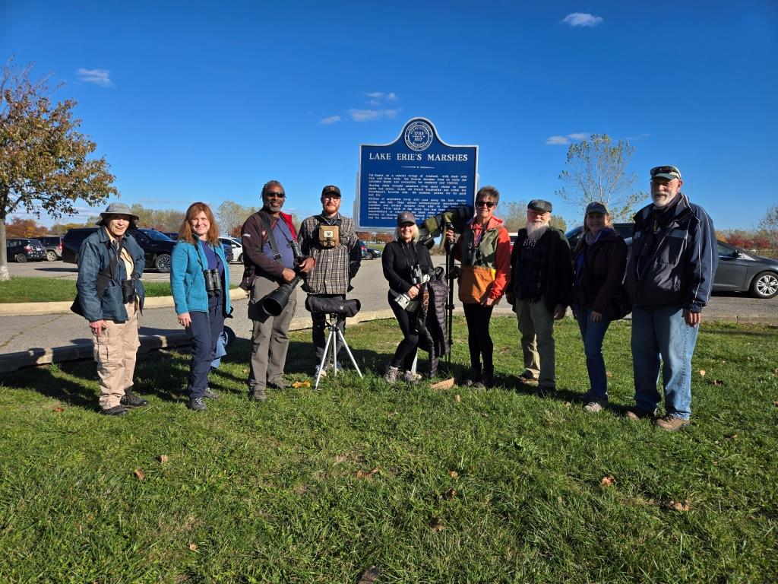
(photo by Don Burlett with the help of a volunteer)

Detroit IWR (Humbug Marsh) - 32 species
Canada Goose
Mallard
Mourning Dove
Killdeer
Ring-billed Gull
Double-crested Cormorant
Great Egret
Great Blue Heron
Northern Harrier
Bald Eagle
Red-tailed Hawk
Red-bellied Woodpecker
Downy Woodpecker
Northern Flicker
Eastern Phoebe
Blue Jay
Black-capped Chickadee
Golden-crowned Kinglet
White-breasted Nuthatch
Carolina Wren
European Starling
Hermit Thrush
American Robin
Cedar Waxwing
American Goldfinch
Dark-eyed Junco
White-throated Sparrow
Song Sparrow
Red-winged Blackbird
Rusty Blackbird
Common Grackle
Northern Cardinal

Lake Erie Metropark – 32 species
Canada Goose
Wood Duck
Mallard
Mourning Dove
Killdeer
Greater Yellowlegs
Ring-billed Gull
Pied-billed Grebe
Great Egret
Great Blue Heron
Turkey Vulture
Sharp-shinned Hawk
Red-tailed Hawk
Red-bellied Woodpecker
Downy Woodpecker
Hairy Woodpecker
American Crow
Black-capped Chickadee
Tufted Titmouse
Ruby-crowned Kinglet
Golden-crowned Kinglet
White-breasted Nuthatch
Hermit Thrush
American Robin
Purple Finch
White-throated Sparrow
Song Sparrow
Red-winged Blackbird
Rusty Blackbird
Orange-crowned Warbler
Yellow-rumped Warbler
Northern Cardinal

Sterling State Park – 19 species
Mute Swan
Trumpeter Swan
Wood Duck
Blue-winged Teal
Northern Shoveler
Gadwall
American Wigeon
Mallard
Ring-necked Duck
Ruddy Duck
American Coot
Pectoral Sandpiper
Bonaparte's Gull
Ring-billed Gull
Double-crested Cormorant
Great Egret
Great Blue Heron
Downy Woodpecker
Yellow-rumped Warbler

