8th Annual Nuthatch Open
September 21, 2019 – (Oakland County) – 4 teams
The 8th Annual Nuthatch Open began with clear skies and moderate temperatures (60’s) but late morning degraded into a hot and humid day. Suddenly, by late morning, the birds had no interest in being active or making even a call, except for blue jays. The four teams scoured Oakland County looking for birds. Many locations were visited many locations in the county including private yards, parks and open areas. It was tough birding and this was witnessed by the markedly lower numbers of bird species recorded. This year, there were just three Open division teams and one Youth team.
In the end, two winners were declared: Open Division – Three Balding Eagles & A Harpy (Mike Mencotti, Tom Pavlik, Scott Jennex and Mary Trombley) won the Open Division with 70 species and the Salas Family (Elizabeth, Emmanuel and Dominic Salas) won the Youth Division with 29 species.

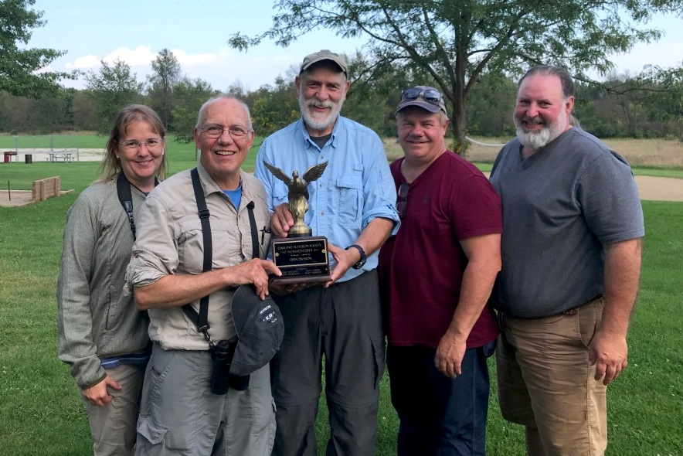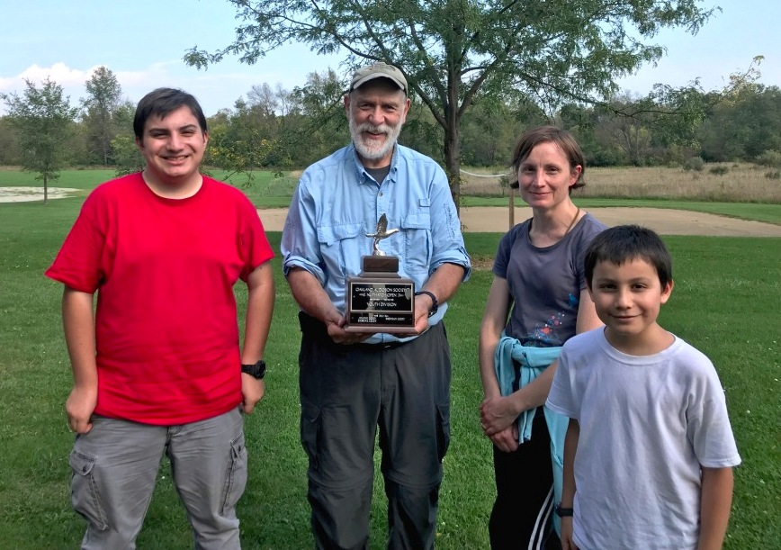

The Open Division also had two other teams: The Three Birdkateers (Don Burlett, Phil Bugosh and Dan Gertiser) finishing second with 55 species and the Quasi-modos (Dave Hoch, TJ Lang and Bill Niemczyk) finishing third with 54 species.
And, of course, we can’t thank our hosts at the tally enough, Alice and Art Marotti. The food was great as usual and they were very welcoming. Well done, Alice and Art.

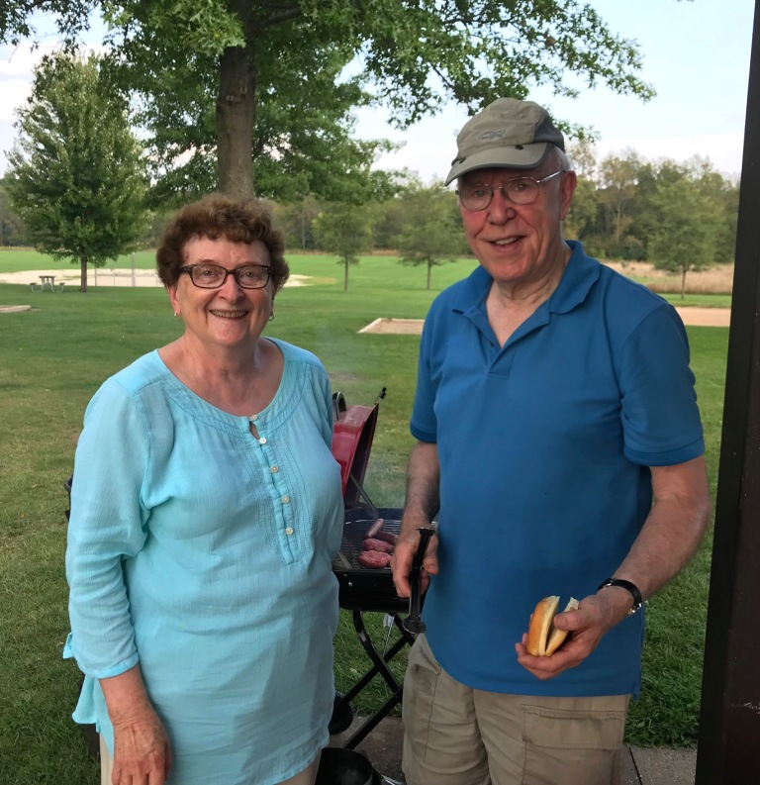

The entire list of species seen by the entire four teams is listed below. Overall, the groups spotted and identified 94 species on the day!!
It was a great outing with proceeds going to the Oakland Audubon Young Birders Program. The Tally Rally at Indian Springs Metropark involved lots of food and chatter about birds seen and not seen. The trophies were awarded and everyone left feeling good about their day in the field.
We hope to see more of our local birders out there next year and we will be looking to unseat the current champions.
Black-bellied Whistling-duck
Canada Goose
Mute Swan
Wood Duck
American Wigeon
Mallard
Green-winged Teal
Wild Turkey
Pied-billed Grebe
Double-crested Cormorant
Great Blue Heron
Great Egret
Green Heron
Black-crowned Night-heron
Turkey Vulture
Osprey
Sharp-shinned Hawk
Cooper’s Hawk
Red-tailed Hawk
American Kestrel
Sandhill Crane
Killdeer
Solitary Sandpiper
Lesser Yellowlegs
American Woodcock
Ring-billed Gull
Rock Pigeon
Mourning Dove
Eastern Screech-Owl
Great Horned Owl
Chimney Swift
Belted Kingfisher
Red-headed Woodpecker
Red-bellied Woodpecker
Downy Woodpecker
Hairy Woodpecker
Northern Flicker
Pileated Woodpecker
American Kestrel
Peregrine Falcon
Eastern Wood-pewee
Eastern Phoebe
Great-crested Flycatcher
Yellow-throated Vireo
Blue-headed Vireo
Philadelphia Vireo
Red-eyed Vireo
Blue Jay
American Crow
Barn Swallow
Black-capped Chickadee
Tufted Titmouse
Red-breasted Nuthatch
White-breasted Nuthatch
Brown Creeper
Carolina Wren
House Wren
Blue-gray Gnatcatcher
Eastern Bluebird
Swainson’s Thrush
American Robin
Gray Catbird
Brown Thrasher
European Starling
Cedar Waxwing
Black-and-white Warbler
Nashville Warbler
Hooded Warbler
Chestnut-sided Warbler
Black-throated Green Warbler
Blackburnian Warbler
Pine Warbler
Bay-breasted Warbler
Chestnut-sided Warbler
Blackpoll Warbler
American Redstart
Magnolia Warbler
Common Yellowthroat
Eastern Towhee
Chipping Sparrow
Field Sparrow
Song Sparrow
Swamp Sparrow
White-throated Sparrow
Scarlet Tanager
Northern Cardinal
Indigo Bunting
Red-winged Blackbird
Eastern Meadowlark
Common Grackle
Brown-headed Cowbird
House Finch
American Goldfinch
House Sparrow

