Birds and Butterflies at Independence Oaks – June 24, 2017
A wonderful group of about 16 birders and butterfly enthusiasts gathered a Independence Oaks County Park in Clarkston on June 24. The weather was near perfect with mild temperatures, a light breeze and blue skies. A fair number of people were new to Oakland Audubon. The group hiked about 5 kilometers through, the open fields, Southern Mesic Forest and Hardwood Conifer Swamp at the park. Birds singing on territories helped with identification and also assisted some birders learning new songs. In total, 40 species of birds were seen and heard.
Butterfly expert, Dwayne Badgero, joined the hike for several hours to assist with butterfly identification. A number of beautiful butterflies, 17 species total, were encountered during the hike including the Great Spangled Fritillary, Baltimore Checkerspot and Eastern Comma. A camouflaged Giant Swallowtail larva was also seen on the Prickly Ash. The larva resembles bird droppings. Dwayne encouraged the larva to extend its red osmeterium which appeared from the head of the caterpillar like horns. Osmeteria are defense organs used to distract and confuse predators. The results of the butterfly count are part of an annual count for the North American Butterfly Association under the Oakland County Headwaters Count. This year only 104 individual butterflies were observed.
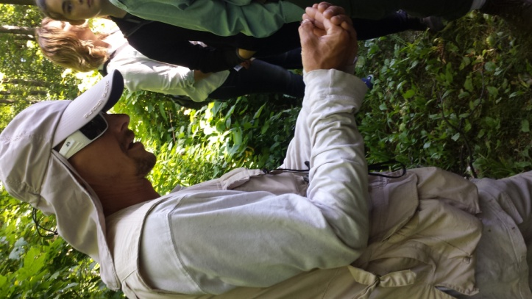
Thanks to Nancy Tar, past OAS/MAS President, for helping with bird identification and leading this hike. The bird checklist has been reported on eBird.
