Great Backyard Bird Count – February 17, 2018

On a chilly Saturday morning, seven Oakland Audubon members braved the weather and potholes to travel to nearby birding locations in Oakland County as part of the Great Backyard Bird Count (GBBC). The GBBC is a major global birding event that takes place for four days in February annually. Birders across the world report sightings to eBird. The United States is by far the biggest contributor, but other countries also participate. As of the end of February 170,759 checklists have been submitted and 6,183 species were seen. GBBC was started in 1998 by National Audubon and the Cornell Lab of Ornithology. It is the first on line real time citizen science project that tracks birds worldwide. Participation has grown over the years. http://gbbc.birdcount.org/
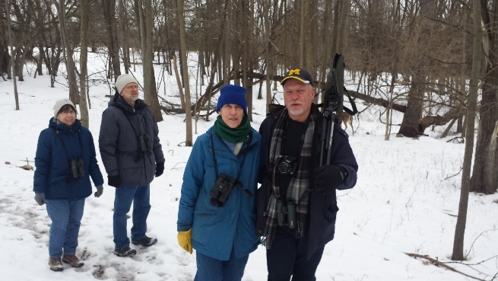
Oakland Audubon visited two local nature centers – the E.L. Johnson Nature Center in Bloomfield Hills and the Lloyd Stage Nature Center in Troy. A small party of hardy birders also stopped at Beaudette Park to view waterfowl. The group saw 28 species and 1 taxa totaling 292 birds. The highlight of the tour was the spotting of a Great-horned Owl which was revealed by mobbing crows. Thanks to the staff at the Lloyd Stage Nature Center and the E.L. Johnson Nature Center for hosting facility tours. The group was greeted on the trail hike by friendly deer.
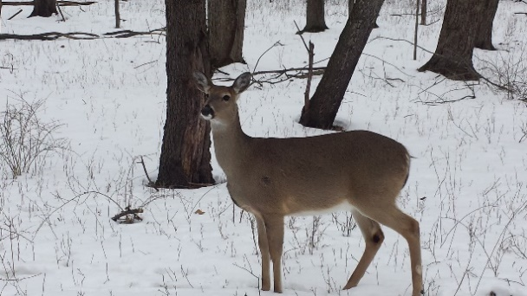
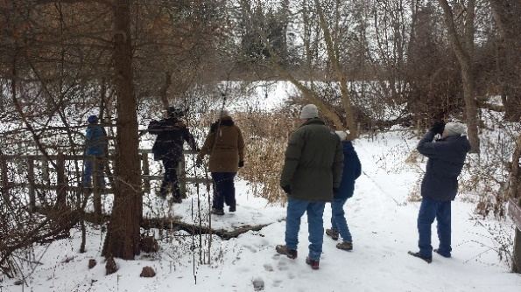

Combined Checklist from Tours – February 17, 2018
Canada Goose 7
Mute Swan 2
Mallard 49
Canvasback 1
Redhead 36
Ring-necked Duck 50
Greater/Lesser Scaup 1
Common Goldeneye 4
Hooded Merganser 10
Common Merganser 7
Wild Turkey 4
Hairy Woodpecker 1
House Finch 11
Ring-billed Gull 1
Mourning Dove 6
Great-horned Owl 1
Red-bellied Woodpecker 5
Downy Woodpecker 6
Hairy Woodpecker 1
Pileated Woodpecker 1
Blue Jay 14
American Crow 9
Black-capped Chickadee 14
Tufted Titmouse 8
White-breasted Nuthatch 7
Fox Sparrow 1
White-throated Sparrow - 1
Dark-eyed Junco 11
Northern Cardinal 10
Pine Siskin 4
American Goldfinch 12
House Sparrow 11

