Discarded Water Bottles – An Environmental Issue
On August 7, 2021, I had the pleasure of working alongside Michigan United Conservation Clubs (MUCC) members at their semiannual Clinton River Clean-up Event. Partnering with Metro-West Steelheaders and the Clinton River Watershed Council (CRWC), this event recruits volunteers to remove trash from the Clinton River and surrounding trails around Yates Park in Rochester Hills.
The specific area I worked at was on the Clinton River’s south bank opposite Coyote Joe’s Nightclub. Coyote Joe’s is located just south of 23-Mile Road on Ryan Road. Hiking eastward along the river bank, I came across a bend in the river where a number of tree logs had accumulated – possibly a beaver dam. Much to my chagrin, this mound of logs also contained discarded, clear plastic water bottles, whiskey and vodka bottles, shoes, scandals, paint cans, and more (comparable to photo shown below by John Cameron on Unsplash).
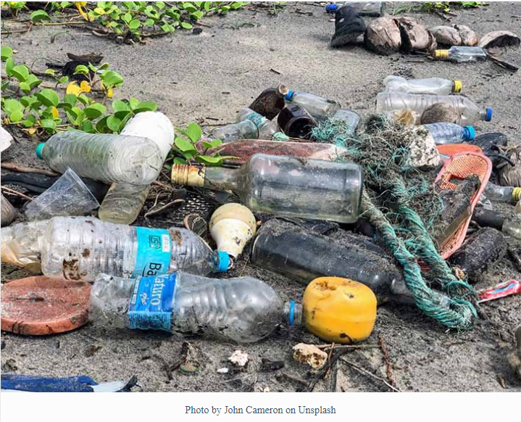
I filled six white trash bags with the debris I could get to! The vast majority of retrieved items were plastic and glass bottles originally containing non-carbonated water and liquor. Although feeling good about corralling and removing these materials from the river bank, it gave me a moment to pause and reflect.
Back in the 1970’s, Michigan’s beaches and roadsides were littered with tons of throw away no deposit, no return cans and bottles. Through a successful petition drive by MUCC, “the bottle bill” measure that Representative Lynn Jondahl (D-East Lansing) introduced was placed on the November 1976 ballot. The proposal successfully passed by over one million votes and became the second container deposit law to be enacted – Oregon being the first in 1971.
Without this law, there is no question that cans and bottles would still be strewn about everywhere and not recycled. By having a 10¢ deposit on returnable cans and bottles, these containers are recycled and our precious rivers and lands are all the more cleaner.
What is noteworthy is that this 10¢ deposit on returnable cans and bottles only applies to carbonated beverages. Back in 1976, I do not believe anyone imaged the proliferation of containers that would be in use for single use beverage containers today.
In February, 2021 Senator Sean McCann (D-Kalamazoo) introduced Senate Bill 0167 requested that the 10¢ deposit be expanded to include non-carbonated beverages with the exception of milk containers. Representative Christine Morse (D-Portage) has introduced the same legislation in the House as part of House Bill 4331. Each of these bills is still at the committee level.
When it comes to recycling numbers, returnables have a much higher participation rate than non-deposit items. The participation rate for returnables averages around 90% in Michigan. The participation rate for non-returnable items average about 20% as part of community recycling programs.
The reason the participation rate is so much higher for returnables is that these containers have worth. As a University of Michigan student back in 1979, I can still remember sitting in the stands after the completion of a football game watching children with large garbage bags collecting all the cans left in the aisles by U of M fans. Although most attendees did not see much value in their empty cans, many industrious youngsters understood the compelling incentive associated with collecting and returning these cans for money.
From an environmental perspective, adding non-carbonated beverage to the 10¢ deposit list will boost recycling participation rates and more importantly help keep our environment cleaner! Let’s see if these bills every come to fruition. Feel free to contact your state representatives at https://michiganlcv.org/at-the-capitol-2/find-your-elected-officials/ and let them know you support measures to keep our environment clean.

Written by: Greg Petrosky
Date: January, 2022

